ALUMNI WEB APPLICATION

Network Portal
System Flowcharts Documentation

Version 1.0 | February 2026 | Sunsys Technologies Pvt Ltd

Legend
The following colour conventions are used across all flowcharts:

Start / End (Terminal)
Frontend — React + Vite (User Actions)
Backend — Node.js API (Processing)
Database — MySQL (Queries)
Email Service — Nodemailer
Decision Point
Error / Rejection

Arrows: Solid arrows show data flow direction. Red arrows indicate error paths.

Flowchart Index
- Flowchart 1 — Alumni Self-Registration, Admin Approval & Email Flow
- Flowchart 2 — Alumni Login Flow
- Flowchart 3 — Forgot & Reset Password Flow
- Flowchart 4 — Admin Manage Alumni Flow

Flowchart 1 — Registration & Approval Flow
This flowchart covers the complete journey from when a new alumni visits the registration page to when the admin approves or rejects their application, including email notifications at each stage.

Key Steps:
- Alumni visits the registration page and fills in their details
- The backend validates the data — checks for duplicate email and hashes the password
- A pending record is saved to the database and a notification email is sent to the admin
- Admin reviews the pending approval list and either approves or rejects the application
- An approval or rejection email is automatically sent to the alumni

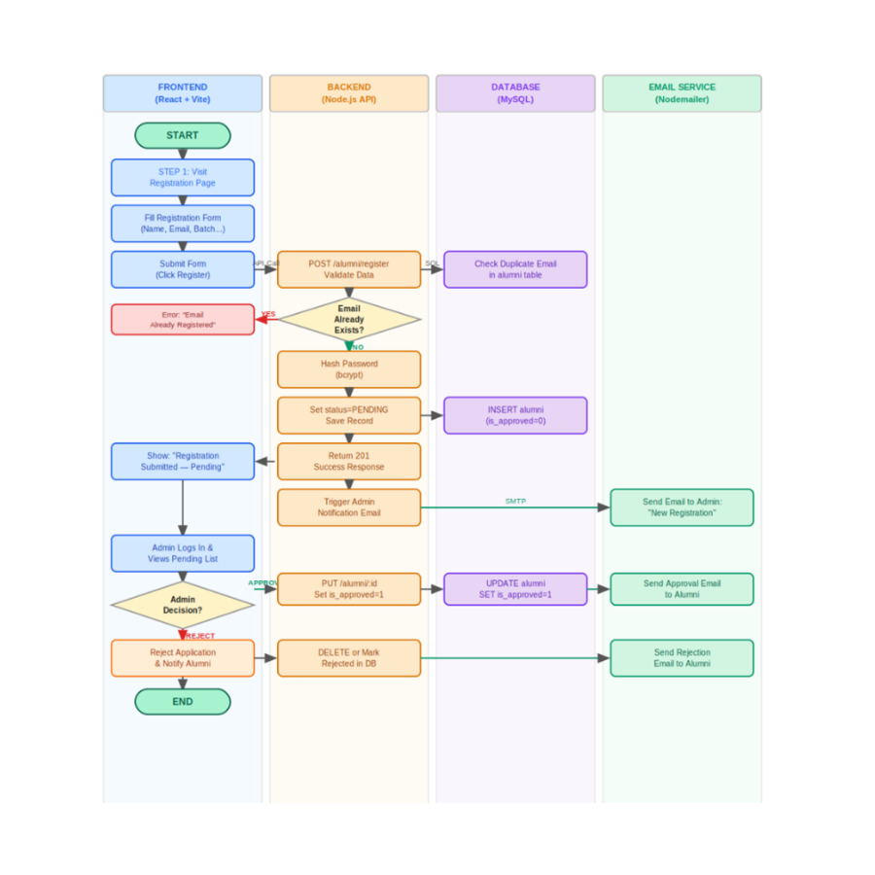

Flowchart 2 — Alumni Login Flow
This flowchart describes the authentication process for alumni users — from submitting their email and password to receiving a JWT token and accessing the alumni dashboard.

Key Steps:
- Alumni enters their email and password on the login page
- The backend looks up the alumni record by email
- The system checks if the account exists, is approved, and if the password matches
- On success, a JWT token is generated and returned to the frontend
- The frontend stores the JWT and redirects the alumni to their dashboard
- Errors at each validation step return meaningful messages to the user

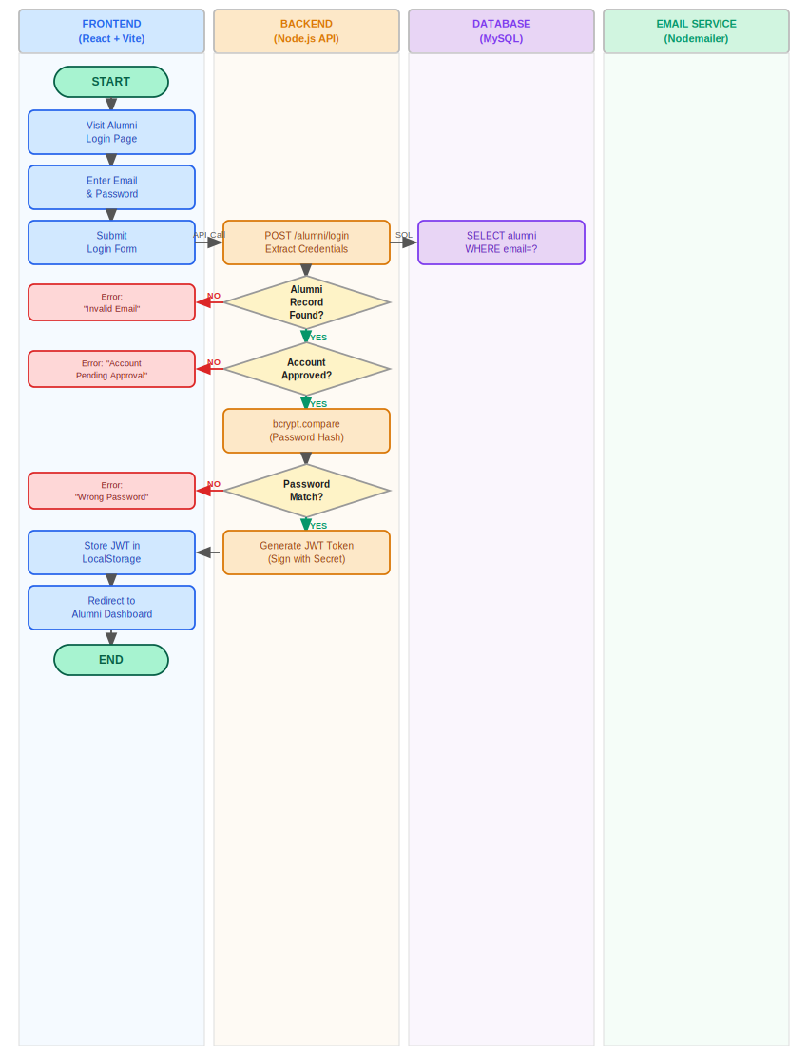

Flowchart 3 — Forgot & Reset Password Flow
This flowchart shows the full password reset cycle — from requesting a reset link via email to entering a new password using a time-limited secure token.

Key Steps:
- Alumni visits the Forgot Password page and submits their registered email
- The backend checks if the email exists in the database
- A secure reset token (with 1-hour expiry) is generated and saved to the database
- An email with the reset link is sent via Nodemailer
- Alumni clicks the link and enters a new password on the Reset Password page
- The backend validates the token expiry, hashes the new password, and clears the token
- Alumni is redirected to login with their new credentials

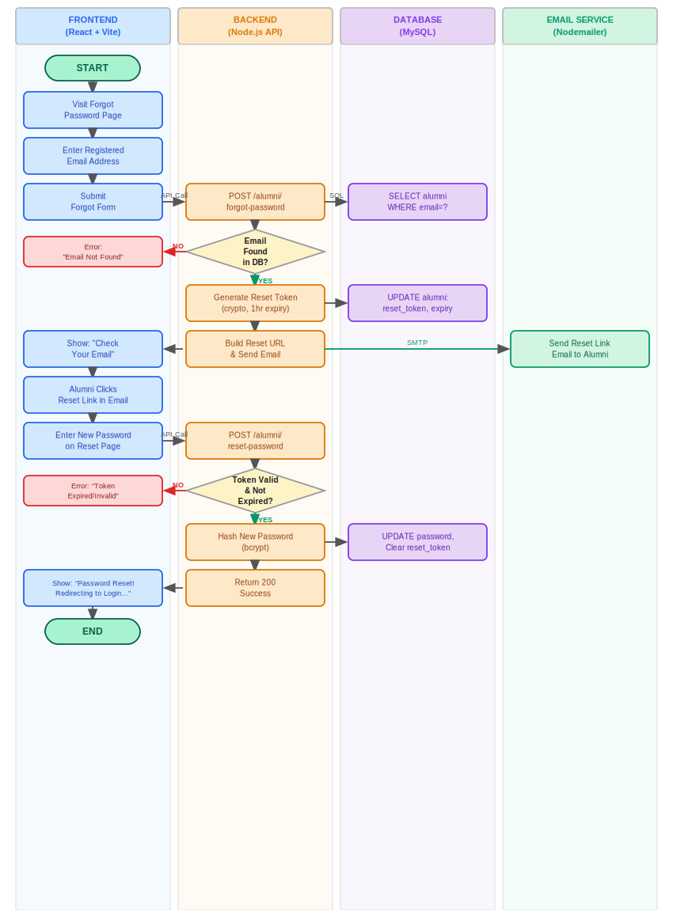

Flowchart 4 — Admin Manage Alumni Flow
This flowchart illustrates how the admin manages the alumni directory — including adding new records, editing profiles, deleting alumni, and searching/filtering the list. It also shows how the dashboard statistics are updated after each operation.

Key Steps:
- Admin logs in with a verified JWT and navigates to the Manage Alumni page
- The system loads all alumni records from the database via GET /alumni
- Admin can choose to Add, Edit, Delete, or Search alumni records
- ADD: Admin fills the form; data is POSTed and a new record is INSERTed into the database
- EDIT: Admin updates fields; a PUT request updates the alumni record
- DELETE: Admin confirms deletion; the record is permanently removed from the database
- SEARCH: Admin filters by name, batch, status; the backend queries with WHERE/LIKE conditions
- After any action, the alumni list is refreshed and dashboard statistics are updated

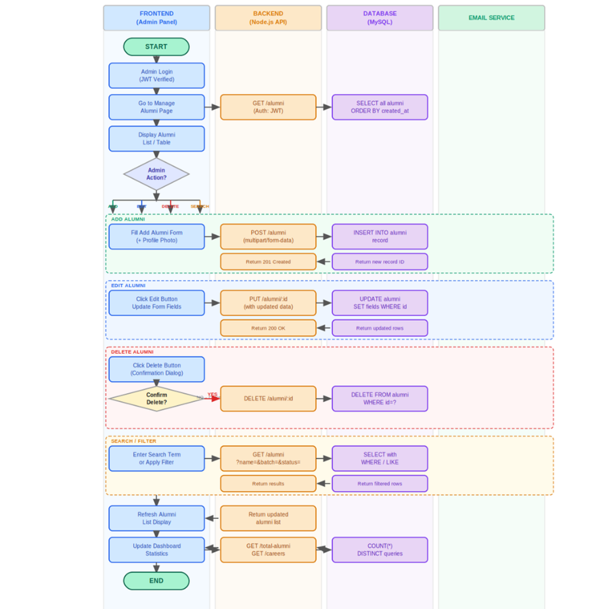

Technology Summary
All flowcharts are based on the following technical stack:

- Frontend: React 18 + Vite + Tailwind CSS — handles user interactions and API calls
- Backend: Node.js + Express.js — processes business logic and REST API endpoints
- Database: MySQL 8.0 — stores alumni records, user accounts, and reset tokens
- Authentication: JWT (jsonwebtoken) — stateless session management
- Password Security: bcrypt — all passwords are hashed before storage
- File Uploads: Multer — handles profile photo uploads (image files only)
- Email Service: Nodemailer with SMTP — password resets and approval notifications

Document prepared by Sunsys Technologies Pvt Ltd — Alumni Connect v1.0

